PIZZA SALES SQL QUERIES
- KPI’S
- Total Revenue
Select SUM (total_price) AS Total_Revenue from pizza_sales;
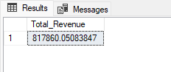
- Average order Value
Select SUM (total_price)/ COUNT(distinct order_id)as Avg_Order_Value From pizza_sales
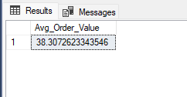

- Total pizzas sold
Select SUM (quantity)AS Total_pizza_sold from pizza_sales
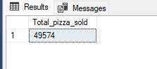
- Total orders
Select COUNT (Distinct order_id)As Total_orders from pizza_sales
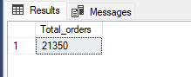

- Average pizzas per order
Select CAST (CAST(SUM(quantity)AS decimal(10,2))/
CAST(COUNT(distinct Order_id)AS decimal(10,2))AS decimal(10,2)) AS Avg_pizzas_per_order from pizza_sales
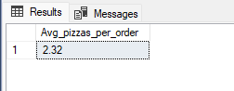

- CHART REQUIREMENTS
Daily trends for total orders
Select DATENAME(DW,order_date) as order_day, COUNT(Distinct order_id) as Total_orders
From pizza_sales
Group by DATENAME (DW,order_date)
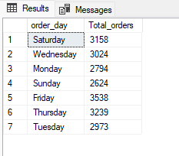

Monthly trend for total orders
Select DATENAME (month,order_date) AS month_name, COUNT(Distinct order_id)AS total_orders
from pizza_sales
Group by DATENAME (month,order_date)
order by total_orders DESC
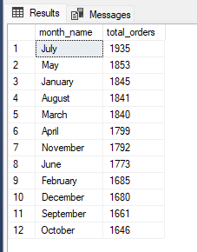
Hourly trend for total orders
Select Datepart(Hour,order_time) as order_hours, count(distinct order_id) as total_orders
from pizza_sales
group by Datepart(Hour,order_time)
order by Datepart(Hour,order_time)
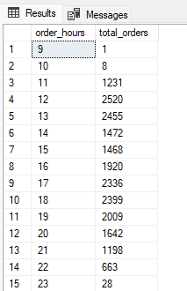

Percentage of sales by Pizza Category
Select pizza_category, SUM(total_price)*100 / (Select SUM(total_price)from pizza_sales) as PCT
from pizza_sales
Group by pizza_category
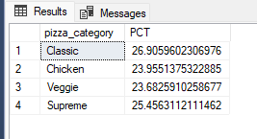
Percentage of sales by pizza size
Select pizza_size,sum(total_price) AS total_sales, SUM(total_price)*100/(select SUM(total_price) from pizza_sales) AS pct
from pizza_sales
Group by pizza_size
Order by pct DESC
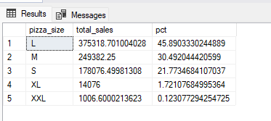
Total pizzas sold by pizza category
Select pizza_category,SUM(quantity) AS Total_quantity_sold From pizza_sales
group by pizza_category
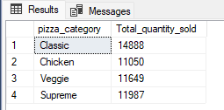
Top 5 Best Sellers by Total Pizza’s sold
Select Top 5 pizza_name,SUM(total_price) AS Total_Revenue from pizza_sales
group by pizza_name
Order by Total_Revenue DESC
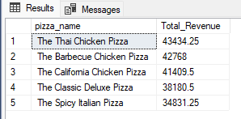

Bottom 5 Worst sellers by Total Pizzas sold
Select Top 5 pizza_name,SUM(total_price) AS Total_Revenue from pizza_sales
group by pizza_name
Order by Total_Revenue
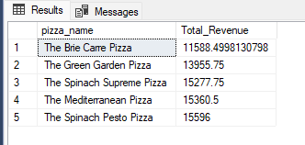
Top 5 pizzas by Quantity
Select Top 5 pizza_name,SUM(quantity) AS Total_quantity from pizza_sales
group by pizza_name
Order by Total_quantity DESC
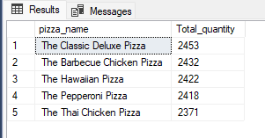
Bottom 5 pizzas by Quantity
Select Top 5 pizza_name,SUM(quantity) AS Total_quantity from pizza_sales
group by pizza_name
Order by Total_quantity ASC
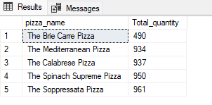
Top 5 pizzas by orders
Select Top 5 pizza_name,COUNT(Distinct order_id) AS Total_orders from pizza_sales
group by pizza_name
Order by Total_orders DESC
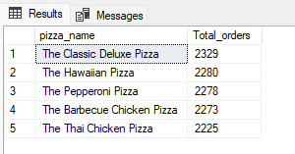
Bottom 5 pizzas by orders
Select Top 5 pizza_name,COUNT(Distinct order_id) AS Total_orders from pizza_sales
group by pizza_name
Order by Total_orders ASC
